✈️ Travel Booking App UI

## 📖 Project Overview
The Travel Booking App UI is a mobile application interface designed using Figma. The application provides users with a simple and attractive interface to search for travel destinations, book flights, and manage their travel plans.
This project was created as part of the UI/UX Design Laboratory to demonstrate the principles of user interface design and user experience.

## 🎯 Objective
To design an intuitive and visually appealing mobile UI for a travel booking platform.
To apply UI/UX design principles such as consistency, hierarchy, and usability in a real-world scenario.

## ✨ Features

Splash/Frame Page
Home Page
Flight Results Page

🛠️ Tools Used
Figma
GitHub

## 🖼️ Screenshots
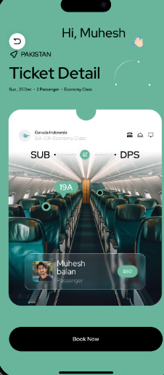
Initial page
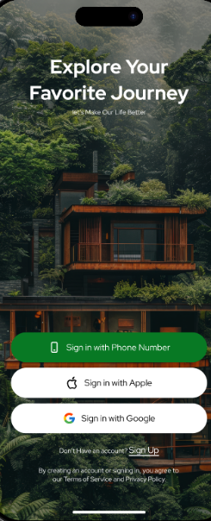

### home page
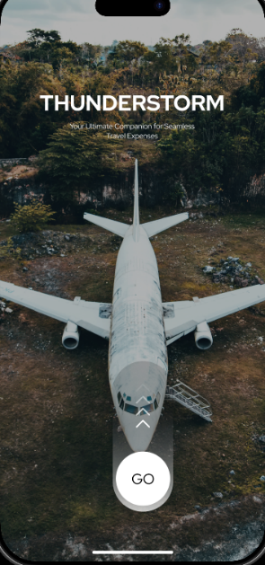
Flight results
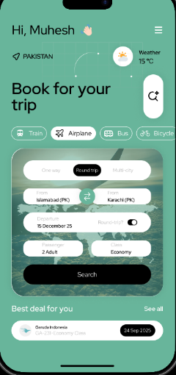
Payment
---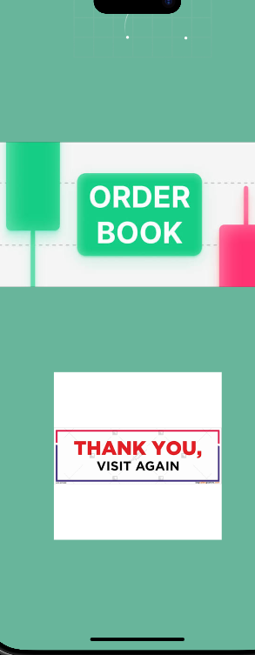

## 🎨 Design Highlights

Consistent green colour theme across all screens
Clean, card-based layout for destinations, flights, and pricing
Rounded corners and soft shadows for a modern, friendly look
Clear visual hierarchy (headings, prices, and CTAs stand out)
Simple, minimal navigation with icon-based bottom bar
Reusable UI components (cards, buttons, payment template)
Transparent fare breakdown for user trust
Consistent typography and spacing for readability
---

## 🔗 Figma Prototype

Paste your Figma Prototype Link here.

https://www.figma.com/proto/X1MWVKIFUL8XU6Vj8St3nN/Thunderstorm--Your-Ultimate-Travel-Companion--Community-?node-id=2006-17&starting-point-node-id=1%3A55&t=PcR8FLyMXiYKarXd-1
---

## 📂 Project Structure
Design Elements
├── Colours – green& black theme
├── Typography – Consistent font hierarchy
├── Buttons – Select, next
└── Icons – Navigation & category icons

## 👨‍💻 Developed By

**Student Name:** _Muhesh Balan S_________________

**Register Number:** _2617013___________________

**Department:** ___1 BCA A______________________

**College:** ____________KAMARAJ_COLLEGE_______________

---

## 📜 License

This project is created for educational purposes only.

